Theme | Copy | Graphic
Oral Health By the Numbers | Florida needs dental therapy. Just look at #TheNumbers #GoDentalTherapy #FloridiansforDentalAccess | 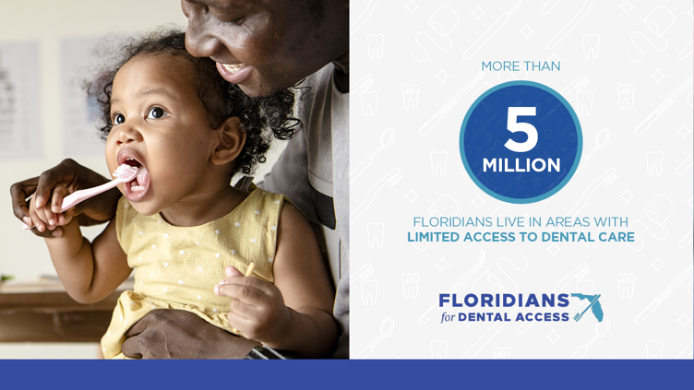
 | Florida needs dental therapy. Just look at #TheNumbers #GoDentalTherapy #FloridiansforDentalAccess | 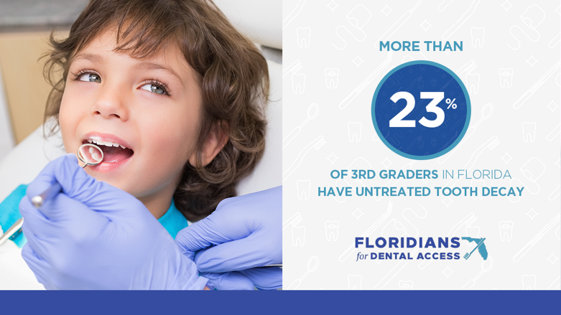
 | Limited access to dental care is costly. Just look at #TheNumbers #GoDentalTherapy #FloridiansforDentalAccess
 | Florida’s seniors suffer from lack of dental care. Just look at #TheNumbers #GoDentalTherapy #FloridiansforDentalAccess | 