Theme | Copy | Graphic
Did You Know? | #DidYouKnow… There are severe shortages of dentists across Florida? #GoDentalTherapy #FloridiansforDentalAccess | 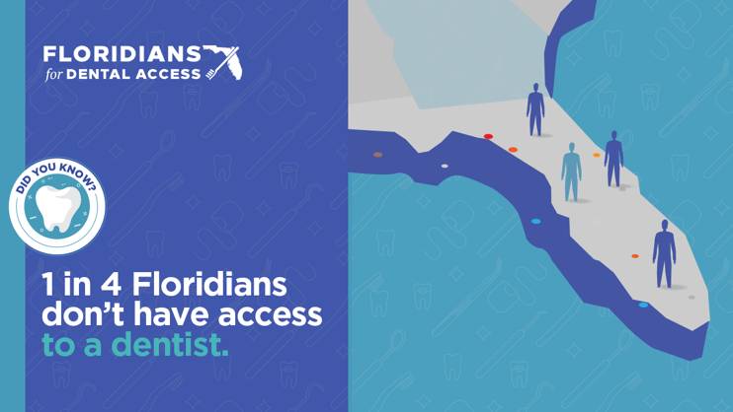
 | #DidYouKnow… Oral health affects your overall health? #GoDentalTherapy #FloridiansforDentalAccess | 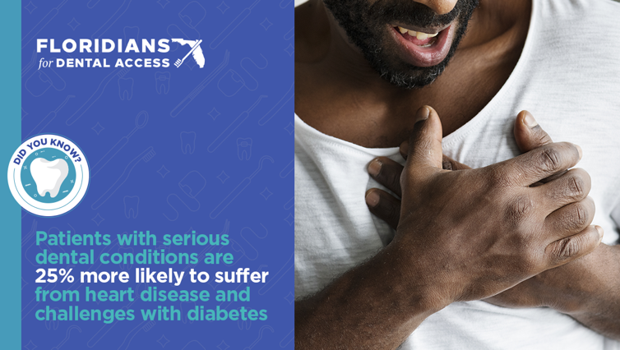
 | #DidYouKnow… Poor dental health affects your quality of life? #GoDentalTherapy #FloridiansforDentalAccess | 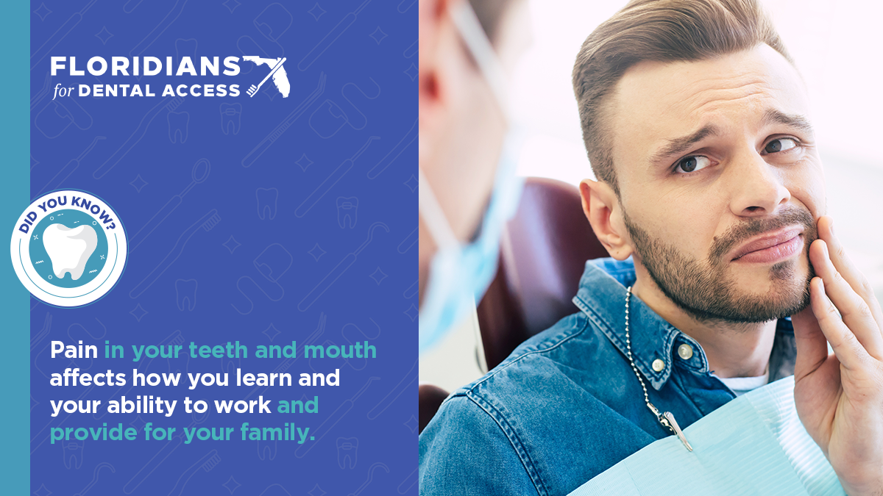
 | #DidYouKnow… Dental therapy can help solve this growing public health crisis? #GoDentalTherapy #FloridiansforDentalAccess | 